**Create and configure IBM Watson platform**

|  |  |
| --- | --- |
| Team ID | PNT2022TMID23589 |
| Project Name | Smart solutions for railways |
| Maximum Marks | 20 marks |

Step-1: Creating IBM Cloud

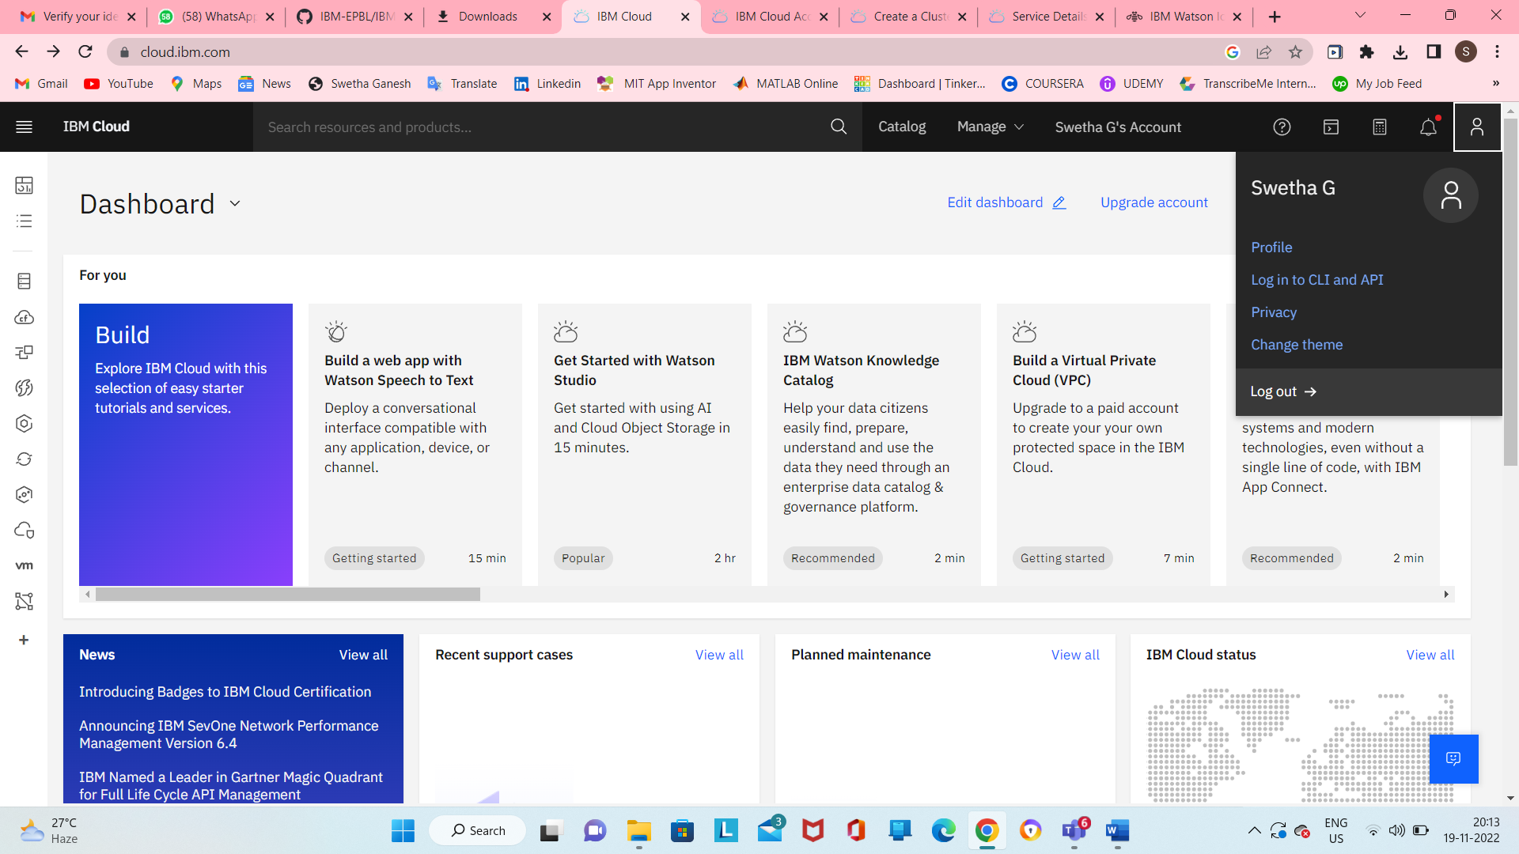

Step-2: Using IBM CLOUD services

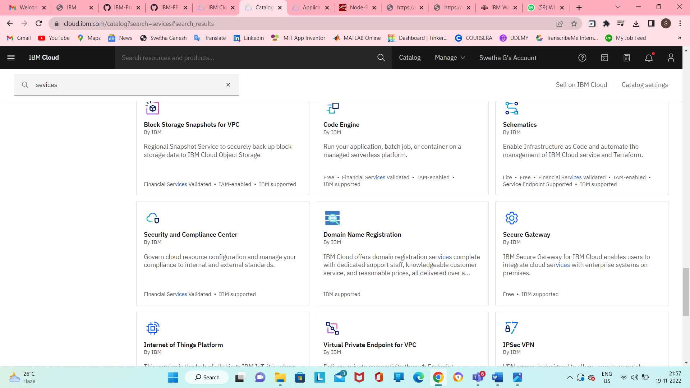

Step-3: Configure the IBM CLOUD service and creating IOT platform

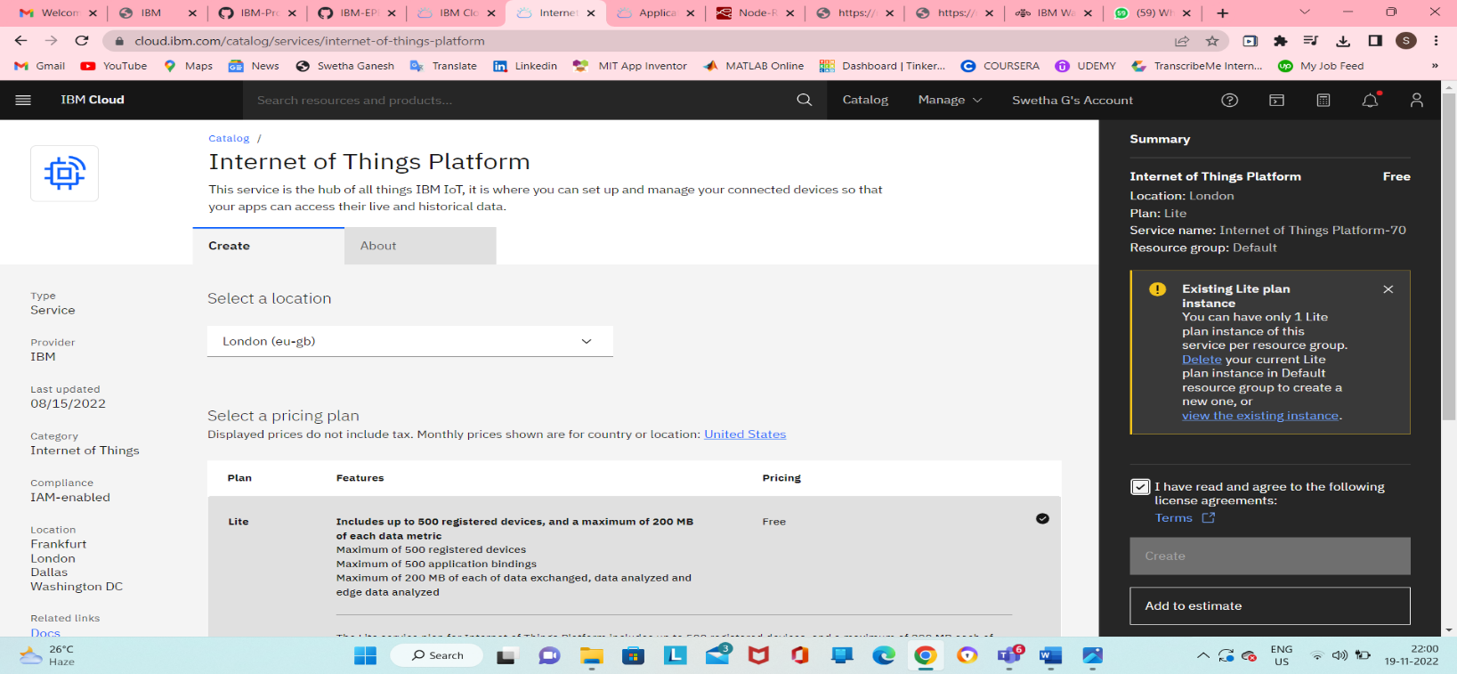

Step4: IBM Watson IOT platform acts as the mediator to connect the web application to IOT devices,hence launching IBM Watson IOT platform.

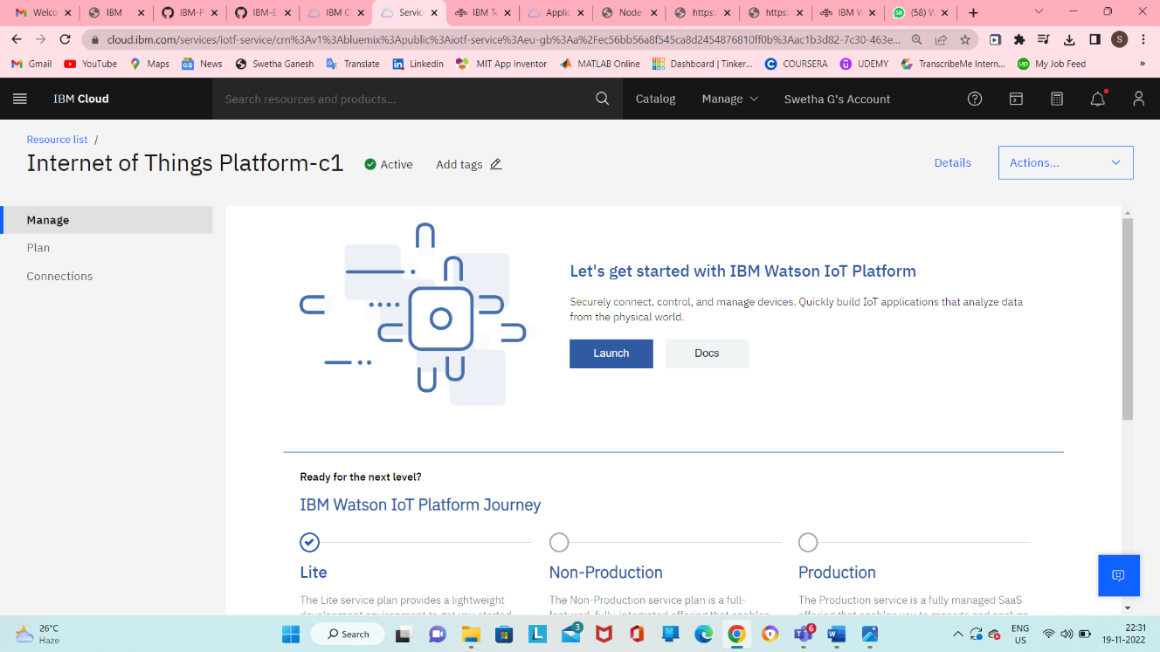

Step 5:IBM Watson IOT platform is created

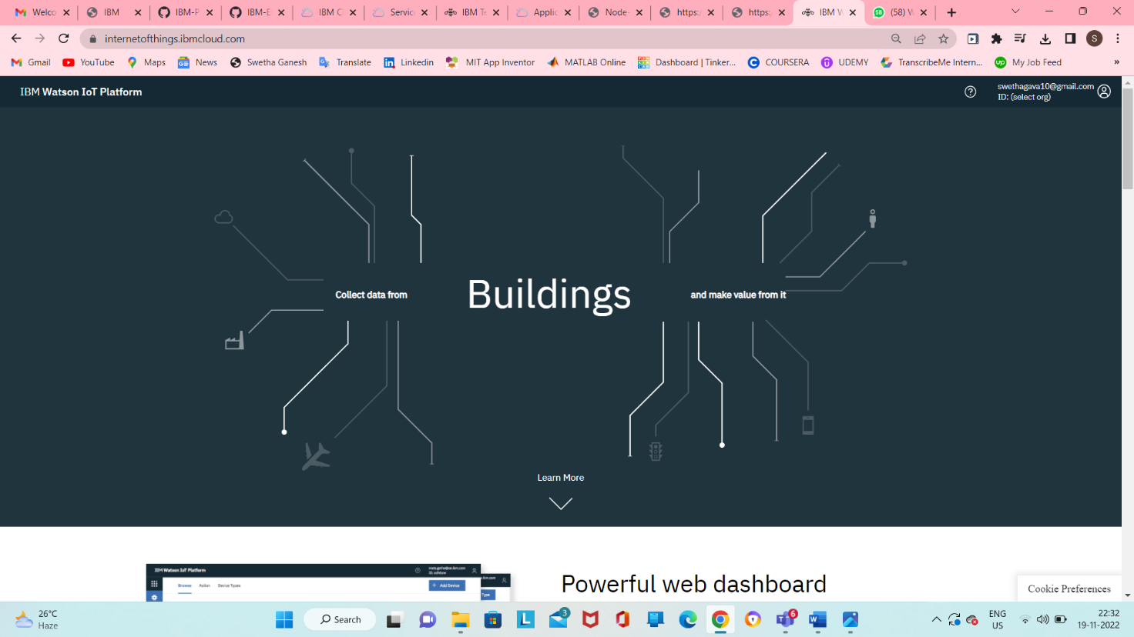

Step 6:In order to connect the IOT device to the IBM cloud, create device in the IBM Watson IOT Platform and get the device credentials.

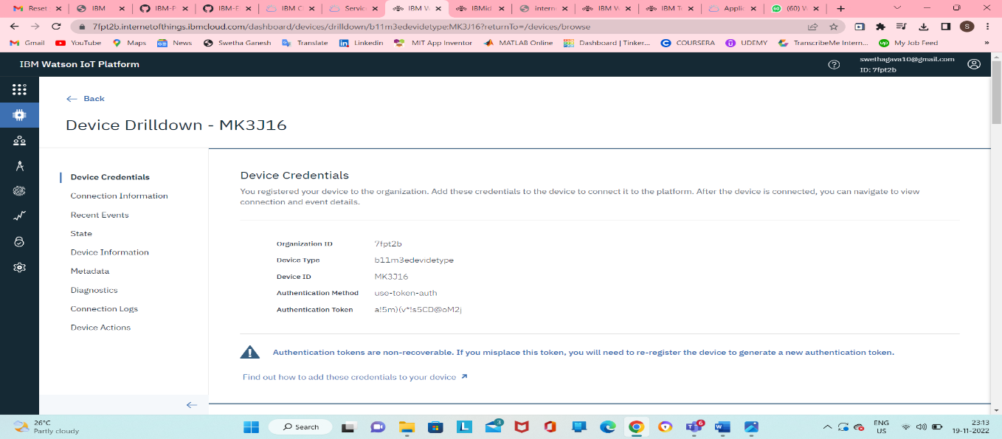

Step-7:Connect the device and start simulating.

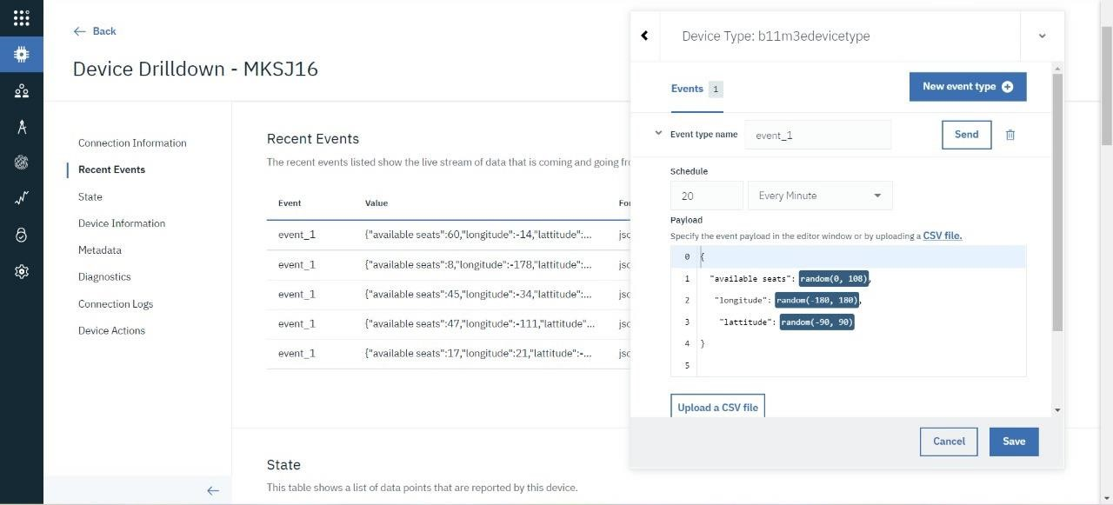

SIMULATION:

The simulation shows the available seats , longitude and lattitude

